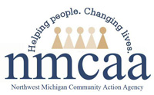

Michigan Ongoing Health and Safety Training Refresher
Per the Michigan Department of Education, annual ongoing health and safety training is required for all childcare providers. This requirement may be fulfilled by taking the following course on MiRegistry: Michigan Ongoing Health and Safety Training Refresher.
This training is offered online. To register, go to www.miregistry.org and select “Search Training” from the main page. On the “Search for Training” page, enter “Refresher” in the Course Title box.
DEADLINE: This course must be completed prior to the startup date of the new program year.
** NOTE: Please be sure to continue in the training until you see the “You Did It” slide. Make sure to click on the box that says “Click Here to Complete this Course.”

Reference: R 400.8131 (12)
P:\Head Start Files\ADMIN\Procedure Manual\Professional Development\MiRegistry Refresher Training 8/22

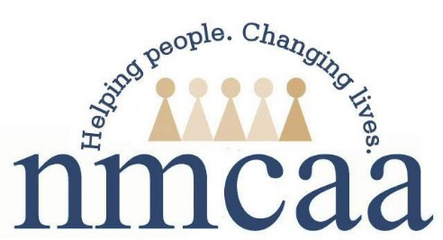

Training Name: Michigan Ongoing Health and Safety Training Refresher
Date: | Training Hours:
Service Area Addressed: Administration | Format: Self-paced (video, PPT, recording)
Training Level: State | Credit Type: Professional
Location Type: Off-site (Virtual) | Location Note: MiRegistry
Training Notes:
Training Level Descriptors:
Cluster: Similar roles from different geographic areas (COPs) Local: Community-based (GSQ Resource Center)
Formal: College classes, technical school, etc. (CDA classes) National: Nationwide (NAEYC, NHSA)
Interagency: Different roles w/in the same organization Regional: Region-based (HS Region V)
(PD offered to all staff regardless of dept.) State: State-level (MiAEYC, MiRegistry)

Staff Name(s) | Center | Position | Email

Distribution: Original to Kristin Ruckle (kruckle@nmcaa.net); Copy to Supervisor 8/22

